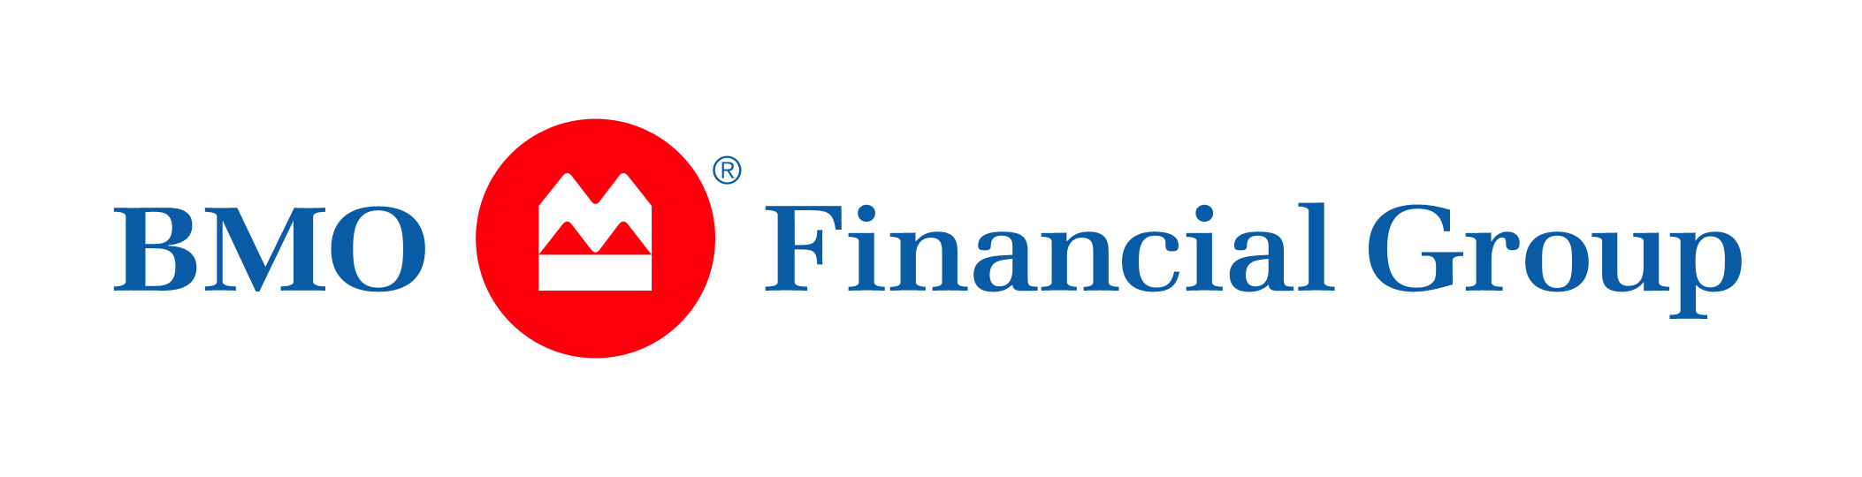

News

FOR IMMEDIATE RELEASE

BMO Financial Group and MasterCard Begin Roll-Out of First in Canada and U.S. Biometric Corporate Card Program
Corporate cardholders will be able to use Selfies and Fingerprint Scans to Verify Their Identify when Making Online Purchases

TORONTO, March 23, 2016 – BMO Financial Group (BMO) and MasterCard today marked the beginning of a phased launch of the first biometric corporate credit card program in Canada and the U.S. that will enable cardholders to verify transactions using facial recognition and fingerprint biometrics when making online purchases.

The introduction of this technology will increase security when making payments that don`t include a face-to-face interaction, and will be integrated seamlessly for easy use in reducing the likelihood of a card being used by anyone who is not the cardholder.

Beginning with corporate cards issued to BMO employees in Canada and the U.S., the MasterCard Identity Check mobile app will prompt participants to:

- Scan fingerprints or snap selfies to validate their identities via biometrics; and
- When verified, return to the merchant site to complete the online purchase

“The use of biometric technology has become more common for consumers looking for convenient and secure ways to make purchases using their smartphones, so this was the natural next step for us as innovators in the payment security space,” said Steve Pedersen, Vice President, Head, North American Corporate Card Products, BMO Financial Group. “Mitigating the risk of fraud is always our top priority, and the inclusion of this technology is going to make payment authentication easier, and strengthen the security of the entire payments ecosystem.”
Mr. Pedersen added that the first phase will test the potential of delivering greater security and convenience using BMO employee corporate cardholders in the U.S. and Canada, including establishing and improving best practices in corporate environments, developing better protection against potential fraud and continually minimizing the need for customer service inquiries. Once complete, the next phase will be to make the technology available to customers more broadly beginning in the summer of 2016.
“With BMO, MasterCard is hosting our first Canadian and U.S. corporate card biometric user engagement. It’s always exciting to introduce biometrics to new cardholders.They quickly realize that they don’t have to sacrifice convenience for security. By snapping a selfie or scanning a fingerprint, the person becomes the password,” said Catherine Murchie, Senior Vice President of North America Processing, Enterprise Security & Network Solutions for MasterCard.
About BMO Financial Group
Established in 1817 as Bank of Montreal, BMO Financial Group is a highly diversified financial services organization and a leading provider of commercial card and treasury solutions based in North America. With total assets of approximately $642 billion as of October 31, 2015, and close to 47,000 employees, the bank also offers a broad range of retail banking, wealth management and investment banking products and services to more than 12 million customers.
About MasterCard
MasterCard, www.MasterCard.com, is a technology company in the global payments industry. We operate the world’s fastest payments processing network, connecting consumers, financial institutions, merchants, governments and businesses in more than 210 countries and territories. MasterCard’s products and solutions make everyday commerce activities – such as shopping, traveling, running a business and managing finances – easier, more secure and more efficient for everyone. Follow us on Twitter @MasterCardNews, join the discussion on the Beyond the Transaction Blog and subscribe for the latest news on the Engagement Bureau.

-30-

BMO Contact: MasterCard Media Contact:
Matthew Duffin Beth Kitchener
416-867-5394 914-249-2058
Matthew.Duffin@bmo.com beth_kitchener@mastercard.com
Corporate Ink Contact: Ketchum Media Contact:
Erin D. Caldwell Miriam Sherkey
617-969-9192 416-355-7410
ecaldwell@corporateink.com miriam.sherkey@ketchum.com

